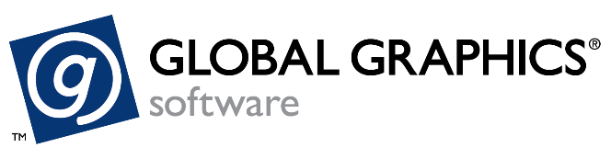

**PRESS RELEASE**

**FOR IMMEDIATE RELEASE**

**Global Graphics Software and Mark Andy expand partnership to integrate SmartDFE into Digital Series HD Press**

**Cambridge, UK and Chesterfield, USA, September 11, 2024:** Global Graphics Software, a Hybrid Software company and the leading developer of smart software components for digital print OEMs, and the leading provider of label and print solutions, Mark Andy, announce an extended collaboration to license SmartDFE™ to drive the new state-of-the-art Digital Series HD HighSpeed 1200 press. The press sets a new industry standard, doubling the speed of its predecessors at 1200dpi resolution, establishing it as the fastest narrow web digital press in the marketplace. It is driven by Mark Andy’s new ProWORX Digital Front End, powered by SmartDFE, which enhances productivity by optimizing prepress workflow and color management.

SmartDFE is the only AI-powered, inline Digital Front End specifically designed for high-speed, single-pass digital inkjet presses. It offers an award-winning suite of components, from job creation and prepress workflow to printhead drive electronics. Powered by the world’s fastest PDF raster image processor, Harlequin RIP®, SmartDFE integrates advanced workflow and color management tools from Hybrid Software.

The Mark Andy Digital Series HD HighSpeed 1200 press is a hybrid solution, seamlessly integrating both digital and flexographic printing. It prints full-color labels at an impressive 480 feet per minute, with 1200dpi resolution and fully variable data capabilities. This high performance is enabled by streaming real-time raster data directly to the printhead electronics provided by Meteor Inkjet, another Hybrid Software company.

“We are thrilled to contribute to the development of this groundbreaking digital press,” said Justin Bailey, Managing Director of Global Graphics Software. “The Digital Series HD HighSpeed 1200 is exactly what SmartDFE was designed for. We are proud of its capabilities and the significant impact it will have on digital printing.”

-more-

Mark Andy Chief Technology Officer Scott Warhover adds: “The Digital Series HD HighSpeed 1200 is a game changer for this industry. Mark Andy is excited to have partners like Global Graphics who help us drive smart innovation that allows our customers to achieve new levels of productivity.”

To enhance flexibility for hybrid (digital/flexographic) users, Mark Andy will offer an optional 12-month subscription to PACKZ, the versatile, all-in-one PDF editor from Hybrid Software, providing users with advanced tools for managing complex label and packaging designs.

Both Global Graphics Software and Mark Andy are exhibiting at Labelexpo Americas in Chicago, September 10th – 12th 2024. Global Graphics Software will be on the Hybrid Software Booth 3015, where the company will demonstrate SmartDFE; Mark Andy will host live demonstrations of the Digital Series HD HighSpeed 1200 on Booth 319 at the following times each day of the show:

* 10:00 AM
* 11:00 AM
* 2:30 PM
* 4:00 PM

Ends

Image:

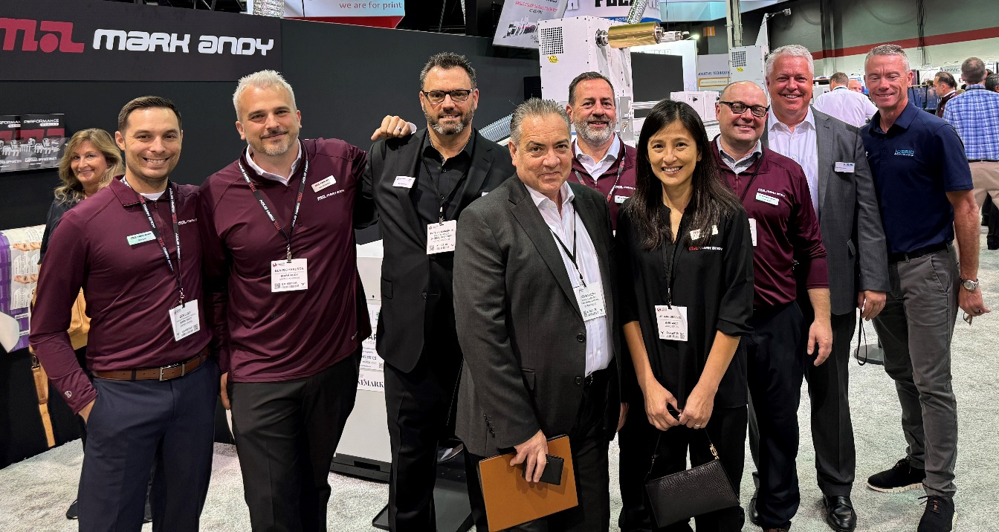

*Caption: The team from Global Graphics Software and Mark Andy celebrate their expanded partnership at Labelexpo Americas 2024 in Chicago.*

**About Mark Andy Inc.**

Mark Andy is a pioneer of the graphic arts and printing industry. As the world’s leading manufacturer of narrow- and mid-web printing and finishing equipment, it supplies leading global brands, including Mark Andy and Presstek printing presses, Rotoflex finishing solutions, as well as a complete line of Mark Andy Print Products consumables and pressroom supplies. All products are backed by the largest customer support team in the industry, minimizing downtime and helping customers be profitable, efficient and at the forefront of innovation. Mark Andy does what it takes to understand each customer’s unique business, the challenges they face and the pressures they feel. It strives to provide products and services that help customers solve their problems and solutions that go a step further, allowing them to excel in their day-to-day operations, ultimately increasing productivity and reaching their full potential. For more information, visit [www.markandy.com](https://go.markandy.com/e/990852/K88P7gNYhl4to6Fv56NyO16Wm678-S/nc9zt/471623388/h/Ls49dCGCT8ubFNN4jY1PyW4kkm3JSFxLbR3xHBujmSo).

**About Global Graphics Software**

Global Graphics Software ([www.globalgraphics.com](http://www.globalgraphics.com)) is a leading developer of smart software components for print OEMs and independent service vendors, including [SmartDFE](https://www.globalgraphics.com/products/smartdfe/)™, [Harlequin Core](https://www.globalgraphics.com/products/harlequin/)™, [ScreenPro](https://www.globalgraphics.com/products/screenpro)™, [PrintFlat](https://www.globalgraphics.com/technologies/printflat)™ and [Mako](https://www.globalgraphics.com/products/mako)™. Customers include [HP, Canon, Durst, Roland, Kodak and Agfa](http://www.globalgraphics.com/company/customers). [The roots of the company go back to 1986](http://www.globalgraphics.com/company/history/) and to the iconic university town of Cambridge, and today the majority of the R&D team is still based near here. Global Graphics Software is a subsidiary of [Hybrid Software Group PLC](https://www.hybridsoftware.group/) (Euronext: HYSG).

**Media Contacts**

**Global Graphics Software:**  
Paula Halpin, PR & Marketing Manager, Global Graphics Software  
[Paula.halpin@globalgraphics.com](mailto:Paula.halpin@globalgraphics.com) | Tel: +44 (0)1223 926017